**Capsule Man** is the name of this game that contain three levels.

Once you click on one of the levels, the game starts. As this game proceeds the screen gradually advances to the right.

The character can jump on top of ground enemies to destroy them, collisions with enemies from the side of the character damage’s the character. The player character should be able to move in any direction. The player character never moves off-screen. If the character fall in the space between the platforms, the game end.

On the top of the screen you can see how many golds you have collected, number of enemies destroyed, and Health to show your health level. You can pause the game from the Pause button and resume the game by clicking the Pause button again. Exit button will bring you back to the Main Menu.

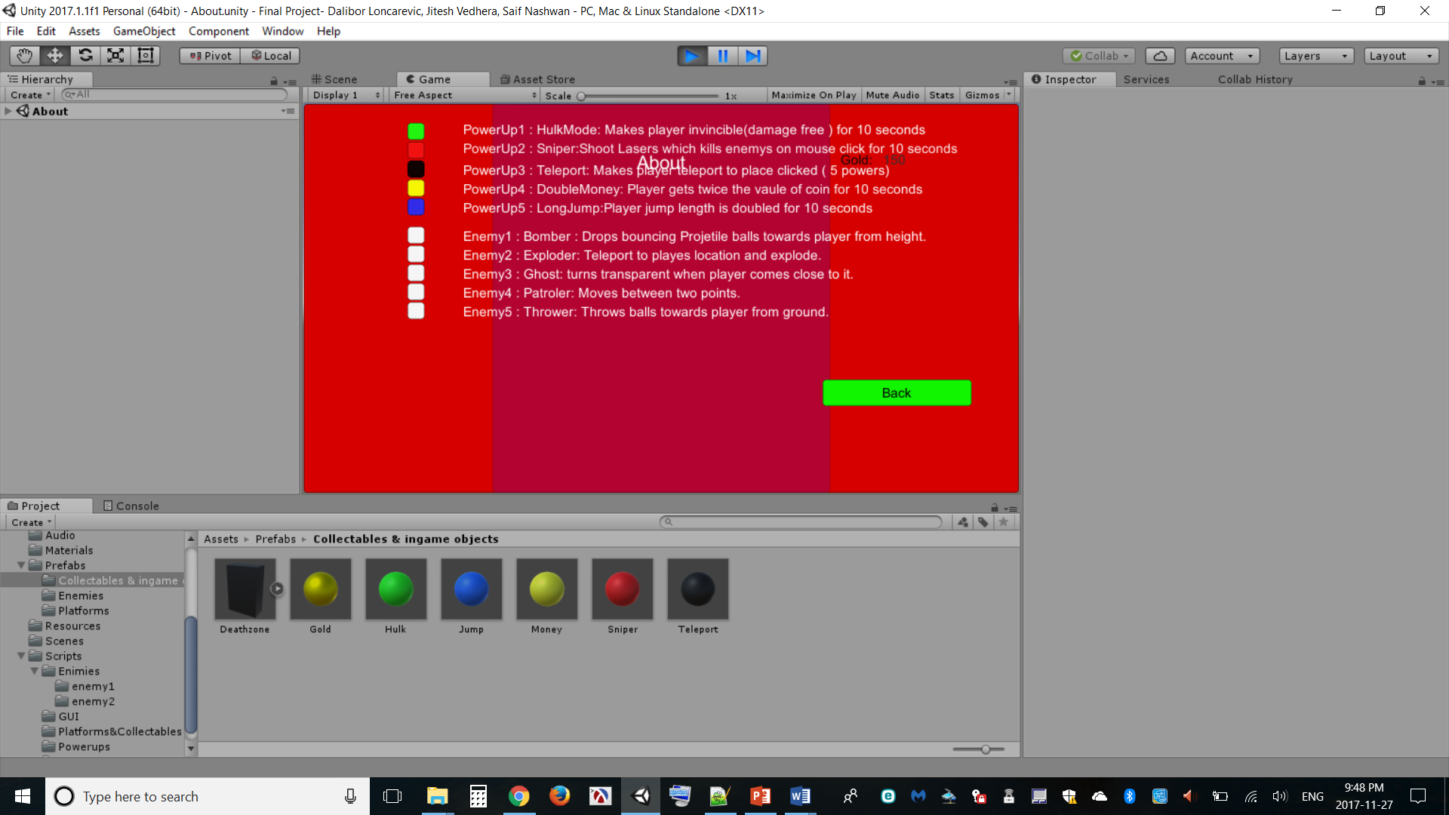Reduce character’s health one point per second when character get in touch with it.

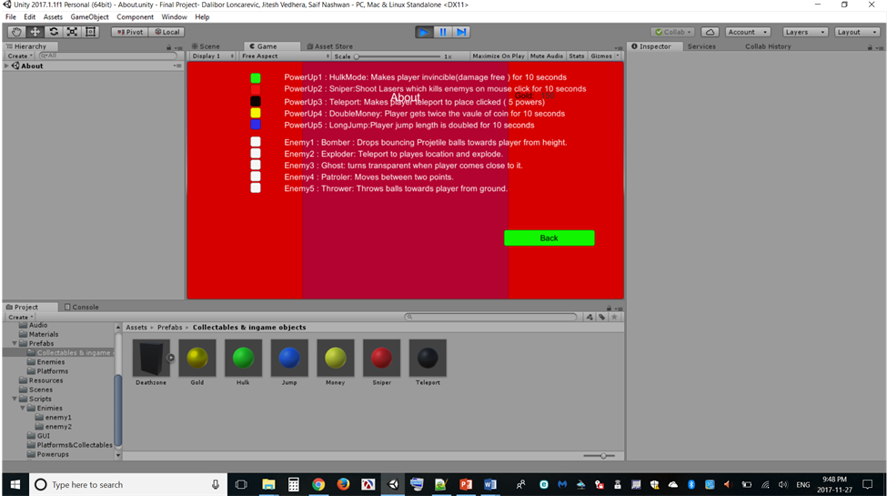Collectable currency

**Five kinds of powerups player’s colour will change to match the powerup mode colour:**

 Make’s player invincible(damage free) for 10 seconds

 Character’s jump length is doubled, last’s for 10 seconds.

 Character gets twice the of coin, last’s for 10 seconds.

 Shoot laser wich kills enemy on mouse click, lasts 10 seconds. Laser goes through multiple enemies and all other objects in the world.

 Makes player teleport to place clicked by mouse. Character is invinsible to any damage for 2 seconds after teleporting. Player get’s five powers of this mode to use. teleporting reset the double jumping mechanic.

**This game contains five enemies,** **collisions with enemies damage’s the character :**

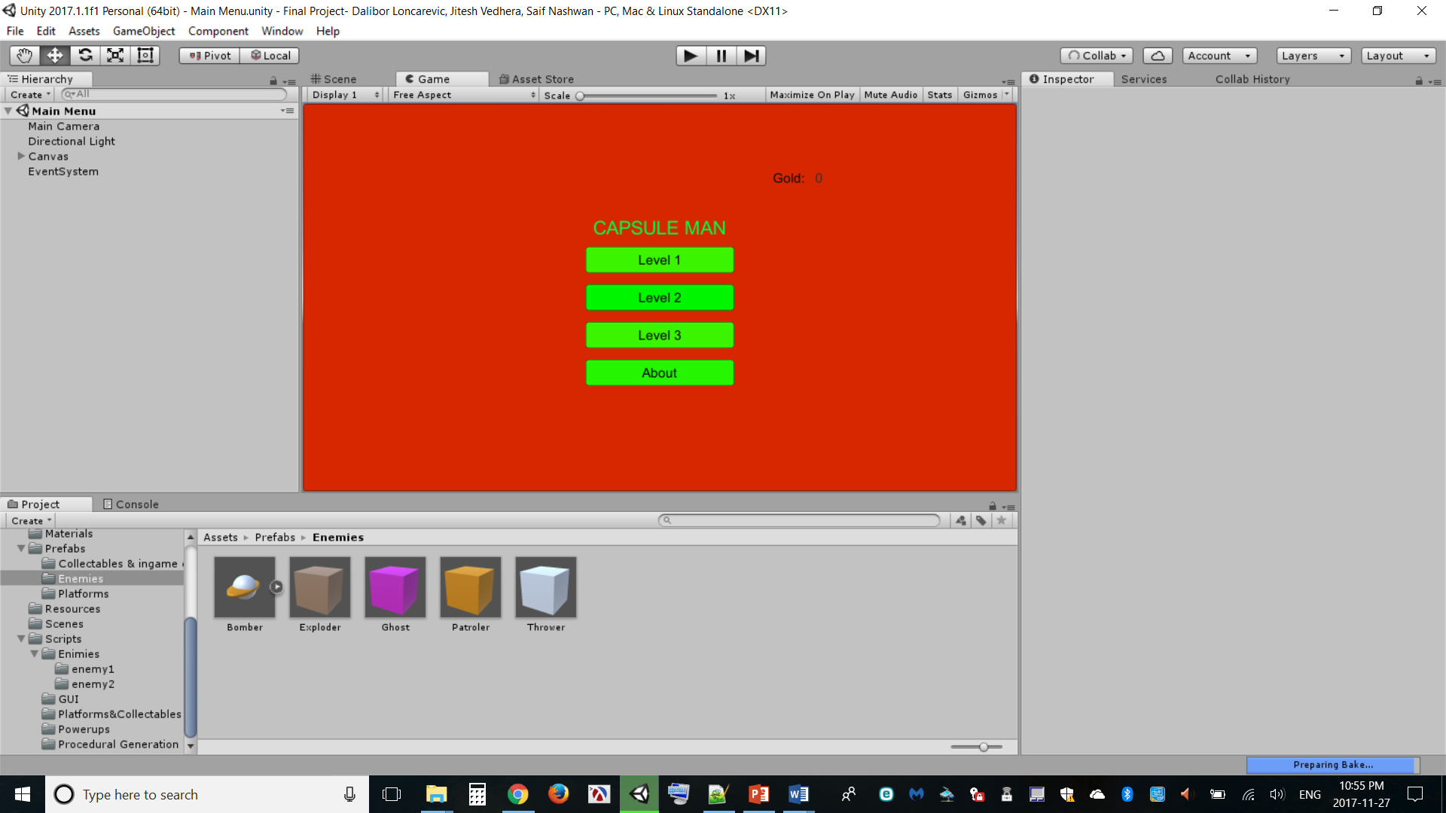 Drops bouncing projectile balls towards player from height. Projectiles last 5 seconds.

 Teleport to players location every 5 seconds and explode. Explosion apploes force to the player. The amount of negative impact is proportional to the player character’s distance.

 Turns transparent when players comes close to it. Transparencey level change depending on the charracter posotion. Character will be invisable when character get closer to it.

 Patrol area between two points by moving back and forth between these points.

 Throws bouncing balls towards player from ground. Projectales disapear after 5 seconds.

**Controllers:**

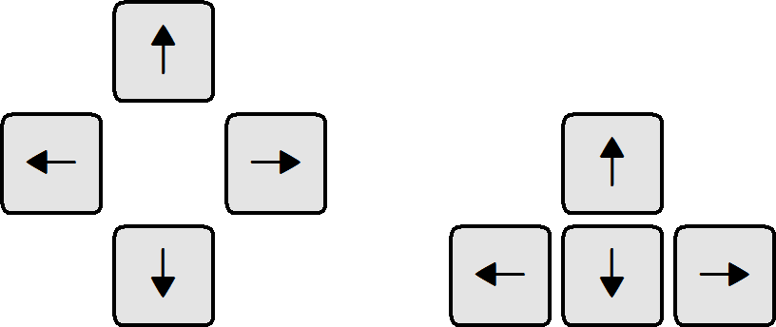 Move character to the right side

 Move character to the left side

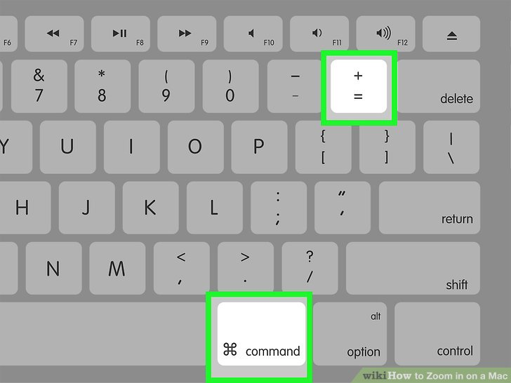 Holding ctrl key make the character run.

 Make’s the character jump, if you tab the button twice it will jump higher.

* Mouse left-click for powers (teleporting and laser)